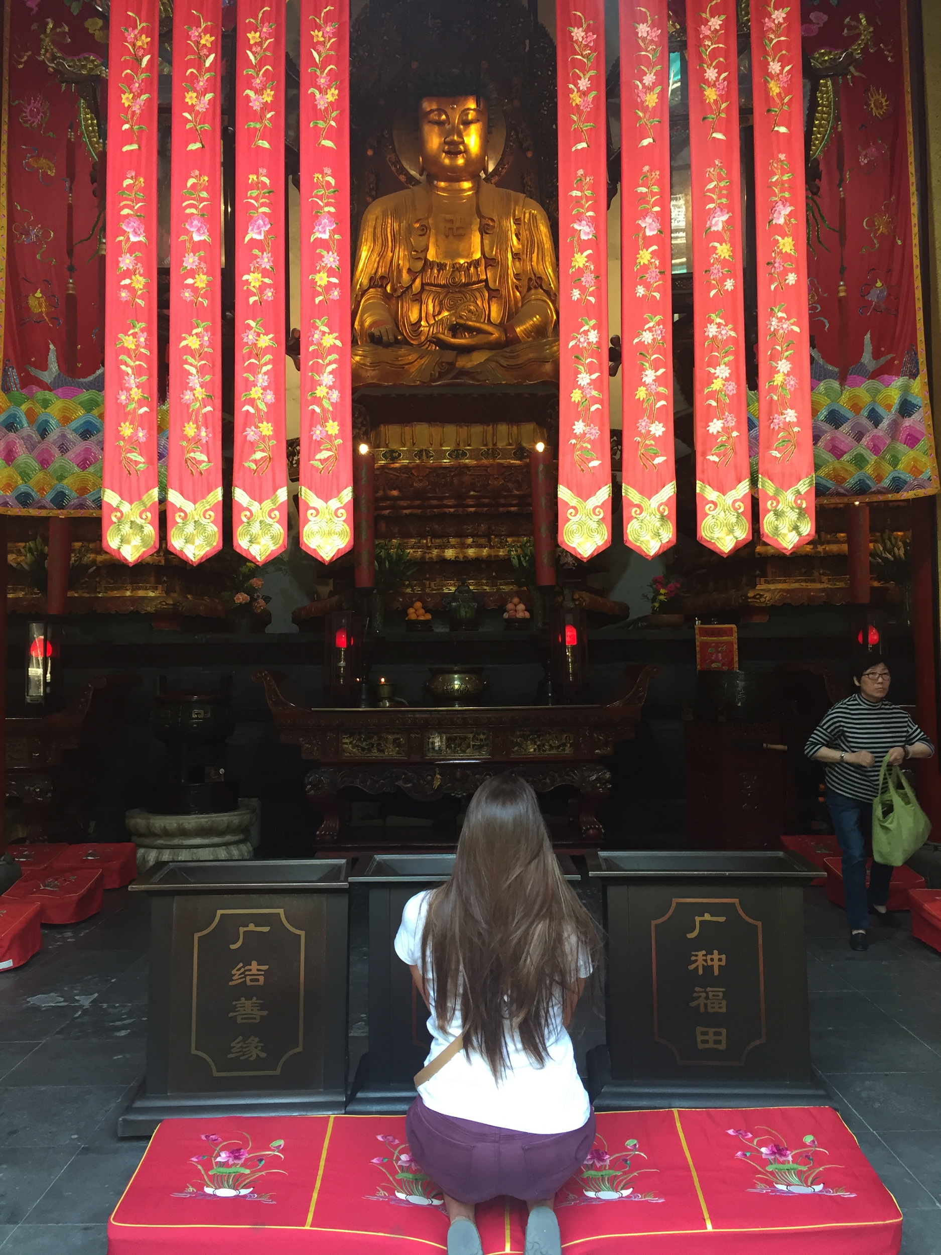
China Spring Term 2017: Mikaela Kitzmiller
Expectation/Initial Impression:
My Chinese background before this trip is extremely minimal to say the least. I have no knowledge of the culture, religious beliefs, education system, or government asides from the fantastic children’s movie Mulan, Kung Fu Panda, or the Karate Kid. As these movies are interesting, they have not been helpful on the actual lifestyle depth of this culture. Realistically, I was aware of these stereotypes in these movies, so I ventured to China with no sturdy expectations. I first noticed how crowded China was. Not only the streets, but the sky was teeming with people. The apartment building stood taller than I thought was possible. I mean, is it safe to live in that high of Altitude? The air was potent with a stench that reminded me of what happens when my brother comes back from wrestling practice and leaves his sweat stained clothes in the bathroom. The colors of the buildings were vibrant as we passed each one of them in our tour bus. The people of the town and their actions were interesting to observe, between the short syllabled phrasing of the Mandarin Language, the way the people stared and nodded (opposed to smiling) I was convinced that everyone was mad all the time. Overall, I am starting out this trip delighted to be on board.

Topic: Influence of Culture and Society on the Younger Generation Opposed to the American Youth.
I chose to dedicate my topic towards the ideals of the youth after being inspired by one of the students at the University visit in Xian. I connected with the students in my group after talking with them explicitly for the brief allotted time. That conversation was minimal, but afterwards it felt as if I have known them all my life. I continue to speak with them over social media and my mind is still continuing to grow and be cultivated with their way of life.

Shanghai
From the beginning of the trip in Shanghai I was fascinated by the children in the streets. From the initial boardwalk we took of Shanghai’s cityscape view, I became awed at the amount of children I saw in the city atmosphere. I come from a family of nurses who constantly told me to protect the children of germs, my mother expressed that she didn’t even bring us into grocery stores. So to see such young babies roaming around the metropolitan of Shanghai blew my mind. As we progressed, I noticed the interactions between us “westerners” and the elementary aged children as we fancied through the Shanghai Museum. They dressed in matching uniform, I find ethnic babies/children to be the utmost adorable so to see them in identical clothing, it was like icing on a cake! The children seem much more shy than american children. They were hesitant to come around us and would often part ways as we walked through the museum, it was almost as if we had a certain forcefield. Occasionally, one would work up the courage to ask us for a picture, and when you replied with yes an immediate gaggle of giggles followed. Along with the Shanghai Museum, which eloquently displayed the ancient Jade Artwork, different paintings and scrolls, coins, and so forth, we visited other museums. We went to the site of the first Congress of Chinese Communist Party, the Residence of Dr. Sun Yat-sen, Residence of Madame Sun/Song Qingling. I have not learned more about a single historical topic than I had in Shanghai. These Museums and residences clearly visualized the importance of each figure in Chinese history for me. The CCP was the organization that was against the Nationalist Party, the first museum, and the help of our guide, explained the historical significance of the museum. Sun Yat-sen started the revolution to overthrow the Chin Dynasty in 1911, to see where he lived was vitalizing. Madame Sun/Song Qingling was, as best described as a “hipster Feminist”. Her entire life was surrounding women and children’s rights. This was poignant considering the value of women at the time (1950 era). Learning about her impact to the world I find inspiring, she reminded me that if you believe in something, nothing is impossible with a pinch of willingness and all of your hard work. We also went to the Yu Garden which embolized the Daoist teachings to a tee. The nature that engulfed the backyard was breathtaking. Everything was completely tranquil and refreshing. I have never felt so calm surrounded by so many tourists. Finally, our last stop in Shanghai was the Jade Buddha Temple. As this place doesn’t identify directly with my topic, it was interesting to observe the socialization of the adults in the Temple. It was evident between those there to praise their gods and those there to watch. The worshipers didn’t speak to anyone other than the words to Buddha. They were suffocated by tourists, but it looked liked they were not even phased. They were in a completely different world than what we were on, they were alone and enliven.
Wuzhen
Wuzhen was stereotyped China to the max. I both loved, and hated it. It was a preserved civilization that was flourished by tourism. The canal system, the bamboo forests, and brimming ecosystem made this bantam town aesthetically pleasing. The transformation of old buildings to museums made Wuzhen intriguing--Old Bed Museums, Cloth looming/dyeing, old hospitals and stores. The architecture of the buildings were built to last and were sensible, however the bridge within a bridge was alluring to ride underneath on a Gondola. This town was what embolized in Mulan it was “China” to a westerner. The rice farmers with the wicker hats as you drove into the town, the bamboo standing tall around pretty much everything, the red lanterns that hung amount the “chinese” edged buildings. It was cool to visit, but the town itself was superficial to the modern day reality of China.

Nanjing
Our first venture was over to the President Palace. Kai-shek used this building for "Headquarters of the Nationalist Government of the Republic of China. It wasn’t until 1947 that it was renamed “Presidential Palace.” Our second endeavor was to the Memorial Museum of Nanjing Massacre. This museum was heartbreaking to walk through. The detail in the statues fortified the somberness in this tragedy. Physically seeing the bones of the individuals that were massacred gravitated this event for me. Reading about how the Japanese invade Nanjing and murdered 300,000 people without any mercy is one thing, but a completely other after seeing it with one’s own eyes. During this event though as we were walking to another site it became perfect time to talk to the student’s that were their to visit. We came across another group of “Westerners” who were in China for a semester. They didn’t speak any Mandarin and were studying the culture on a deeper level than we were doing, it was interesting to compare stories of people taking our picture, the different food variety, and the struggles of the public “Squatty Potty’s”. The Chinese students that we spoke with were high school aged. Their english was good enough to hold a mediocre conversation with. The one’s that we spoke with were open and charming, something I haven’t seen too much of. Our time talking was only in passing, so I collected more from their actions. They spoke with confidence, voice not shaking, and they held eye contact the entire time. Our last day in Nanjing we used to visit Sun Yat-sen’d Mausoleum and the old examination site. The Mausoleum was outside the city, there were 392 stairs representing the amount of people that lived in Nanjing at the time. The heading is inscribed with a translation that means “What is under Heaven is for all” meaning that whoever lives in China is a part of Heaven. Sun Yat-Sen is known as the Father of Modern China so this place in itself is sacred. The examination site was interesting. The seat where the students took their tests were tiny and look uncomfortable, I absolutely cannot imagine the pressure the kids use to be under when undergoing these exams.
Xian
In Xian we made a stop to the Terracotta Warriors, The Grand Mosque, The Big Goose Temple, and a meeting with the University students. The Terracotta warriors were an elegant story. I find it interesting that an Emperor would have to many soldiers created to protect him, when in reality, a unified nation can overthrow any amount of power that is thrown their way. The Grand Mosque was beautiful. I liked to see the minute details between things such as this Mosque created for the Muslims and the Temples for the Buddhist followers. At this location the e was a mother playing with her two daughters as her husband worshipped inside the Mosque. The mom shushed the children to keep them in line, but that was as far as the discipline went. The children obeyed and happily went about popping the bubbles the mother blew their way. What was interesting in this situation was how gentle the mother was to the children when in reality, the mother’s life is far from gentle. In this society, women are still treated lower than they should be, not being allowed to pray with the men. We were surprised that she was allowed into the Mosque. The Big Goose Temple was interesting to witness as well. The University students were my favorite part. My group of girls were relaxed to ask me any question. The language barrier was extremely minimal and our conversations were very versatile. There were a few girls that talked out more than others, but everyone seemed to be sweet and attentive to me. Their dreams and aspirations are high, many of them want to continue their knowledge and become lawyers or translators. Many are traveling out of China to different parts of the world. I had the pleasure to get to know this one girl to more detail. She contacted me over WeChat and we have been communicating ever since. We compare cultural things explicitly, anything from our favorite foods, to dating, to tv show stereotypes. She connected with me so well, she even asked me to give her an English name, I resorted on Jane.
Yanan
In Yanan we visited the Revolutionary Memorial Hall, the old site of Wangjiaping who was the former central military commission, the old site of Zaoyuan which is the former secretariat of the Central Committee. Yanan was a smaller town up in the mountains. The people definitely acted different than those in the previous cities. There were many other people staring and taking our pictures. The people acted more conserved and straightforward, not wanting to socialize.
Beijing
In Beijing we covered a lot of ground. We went to Tiananmen Square, The Forbidden City, The Temple of Heaven, The Great Wall, Summer Palace, and The Olympic Games Site. I want to start off by saying that the Architecture in China has been absolutely breathtaking, however, nothing compares to these experiences we have had in Beijing. The views from the top of The Forbidden City and The Great Wall might be the most stimulating view I have ever seen. Tiananmen Square was the localizing part outside both the mausoleum for Mao and the entrance gate to the Forbidden City. The Forbidden City is like another world inside of a world. This would be a place to go to when no one else was there. To see this building in it’s cultural relevance would be that in a dream. Thee Temple of Heaven is an interesting concept. I am not a follower of the Chinese religious trio, but to imagine how important this Temple was is bizarre. I feel like I am not worthy enough to have stepped foot in such a place. Beijing was phenomenal.
Final Impression
China’s history is incredibly rich. I truly don’t believe that if I spent 10 years their that I could fully understand and see each of the culturally important places. Going to China reminded me how, if you do things thoroughly the first time, how life can last forever. The minimal things that I cared about when stepping out of our first tour bus--the smell, sights, stares, strange foods--don’t even compare to the impact this country has had on my young life this far.

